OPERATING SYSTEM

Course code: CSE 316
Section: K18GE



Submitted by:-
Name: Nurul Haque
Roll No.: 48
Registration No.: 11903516
E-mail :- nurulhaque274@gmail.com
GitHub Link: https://github.com/nurulhaque274/Operating-System

Submitted to:-
Name of the faculty: Milanjit Kaur

Department of Intelligent Systems
School of Computer Science Engineering
Lovely Professional University, Jalandhar
APRIL-2020

Program code.
#include<stdio.h>
void rr(int no,int remt[10],int Cur_t,int arT[10], int bsT[10]);
int main()
{
int Proc_no, j,no,CurT,RemProc,indicator,time_quan, wait,tut, arT[10], bsT[10],remt[10],x=1;
indicator = 0;
wait = 0;
tut = 0;
printf("\nEnter number of processes ");
scanf("%d",&no);
RemProc = no;
printf("\nEnter the arrival time and burst time of the processes\n");
for(Proc_no = 0;Proc_no < no;Proc_no++)
{
printf("\nProcess P%d\n",Proc_no+1);
printf("Arrival time = ");
scanf("%d",&arT[Proc_no]);
printf("Burst time = ");
scanf("%d",&bsT[Proc_no]);
remt[Proc_no]=bsT[Proc_no];
}
printf("The details of time quantum are as follows:\n");
printf("The time quantum for first round is 6.\n");
time_quan=6;
CurT=0;
for(Proc_no=0;RemProc!=0;)
{
if(remt[Proc_no]<=time_quan && remt[Proc_no]>0)
{
CurT+=remt[Proc_no];
remt[Proc_no]=0;
indicator=1;
}
else if(remt[Proc_no]>0)
{
remt[Proc_no]-=time_quan;
CurT+=time_quan;
}
if(remt[Proc_no]==0 && indicator==1)
{ printf("%d",Proc_no);
RemProc--;
printf("P %d",Proc_no+1);
printf("\t\t\t%d",CurT-arT[Proc_no]);
printf("\t\t\t%d\n",CurT-bsT[Proc_no]-arT[Proc_no]);
wait+=CurT-arT[Proc_no]-bsT[Proc_no];
tut+=CurT-arT[Proc_no];
indicator=0;
}
if(Proc_no==no-1){
x++;
if(x==2){
Proc_no=0;
time_quan=10;
printf("\nThe time quantum for second round is 10. \n");
}
else{
break;
}
}
else if(CurT >= arT[Proc_no+1]){
Proc_no++;
}
else{
Proc_no=0;
}
}
rr(no,remt,CurT,arT,bsT);
return 0;
}
void rr(int no,int remt[10],int Cur_t,int arT[10], int bsT[10]){
float avg_wait,avg_tut;
int i,j,n=no,temp,btime[20],Proc_no[20],w_time[20],tut_t[20],total=0,loc;
printf("\nThird round with least burst time.\n");
for(i=0;i<n;i++)
{
btime[i]=remt[i];
w_time[i]=Cur_t-arT[i]-btime[i];
Proc_no[i]=i+1;
}
for(i=0;i<n;i++)
{
loc=i;
for(j=i+1;j<n;j++)
{
if(btime[j]<btime[loc]){
loc=j;
}
}
temp=btime[i];
btime[i]=btime[loc];
btime[loc]=temp;
temp=Proc_no[i];
Proc_no[i]=Proc_no[loc];
Proc_no[loc]=temp;
}
for(i=1;i<n;i++)
{
for(j=0;j<i;j++){
w_time[i]+=btime[j];
}
total+=w_time[i];
}
avg_wait=(float)total/n;
total=0;
printf("________________________________________________________________");
printf("\nProcess\t\tBurst time\t\twaiting time\t\tTurnaround Time\n");
printf("________________________________________________________________");
for(i=0;i<n;i++)
{
tut_t[i]=btime[i]+w_time[i];
total=total + tut_t[i];
printf("\nP%d\t\t\t%d\t\t\t%d\t\t\t%d",Proc_no[i],btime[i],w_time[i],tut_t[i]);
}
printf("\n________________________________________________________________\n");
avg_tut=(float)total/n;
printf("\n\nAverage waiting time = %f",avg_wait);
printf("\nAverage turnaround time = %f\n",avg_tut);
}

ALGORITHM:
- Take all the inputs from the user.
- Arrange the processes in two different queues.
- Put the two different queues into single queue according to arrival time and priority.
- Select that process which has minimum arrival time and minimum burst time.
- After completion of process, select next process which has minimum arrival time and minimum burst time.
- After completion of all processes, summarize the process with their completion time.

COMPLEXITY OF THE ALGORITHM:
The complexity of the scheduling algorithm is O(1).

CONSTRAINTS
- Round robin CPU scheduling algorithm cannot be implemented in real time operating system due to high context switching, large waiting time, large response time, large turnaround time and less throughput.
- The proposed algorithm improves all the drawbacks of round robin CPU scheduling algorithm.
- It reduces the problem of starvation and also implement the concept of aging.

Characteristics
- Round robin is a pre-emptive algorithm.
- The CPU is shifted to the next process after fixed interval time, which is called time quantum/time slice.
- The process that is preempted is added to the end of the queue.
- It is a real time algorithm which responds to the event within a specific time limit.
- Round robin is one of the oldest, fairest, and easiest algorithm.
- Widely used scheduling method in traditional OS.

Advantages
- It doesn't face the issues of starvation.
- All the jobs get a fair allocation of CPU.
- It deals with all process without any priority.
- Once a process is executed for a specific set of the period, the process is preempted, and another process executes for that given time period.
- Allows OS to use the Context switching method to save states of preempted processes.
- It gives the best performance in terms of average response time.

Disadvantages
- If slicing time of OS is low, the processor output will be reduced.
- This method spends more time on context switching
- Its performance heavily depends on time quantum.
- Priorities cannot be set for the processes.
- Round-robin scheduling doesn't give special priority to more important tasks.
- Decreases comprehension
- Lower time quantum results in higher the context switching overhead in the system.

CODE SNIPPET:
for(i=0;i<n;i++)
{
loc=i;
for(j=i+1;j<n;j++)
{
if(btime[j]<btime[loc]){
loc=j;
}
}
temp=btime[i];
btime[i]=btime[loc];
btime[loc]=temp;
temp=Proc_no[i];
Proc_no[i]=Proc_no[loc];
Proc_no[loc]=temp;
}
for(i=1;i<n;i++)
{
for(j=0;j<i;j++){
w_time[i]+=btime[j];
}
total+=w_time[i];
}

TEST CASE
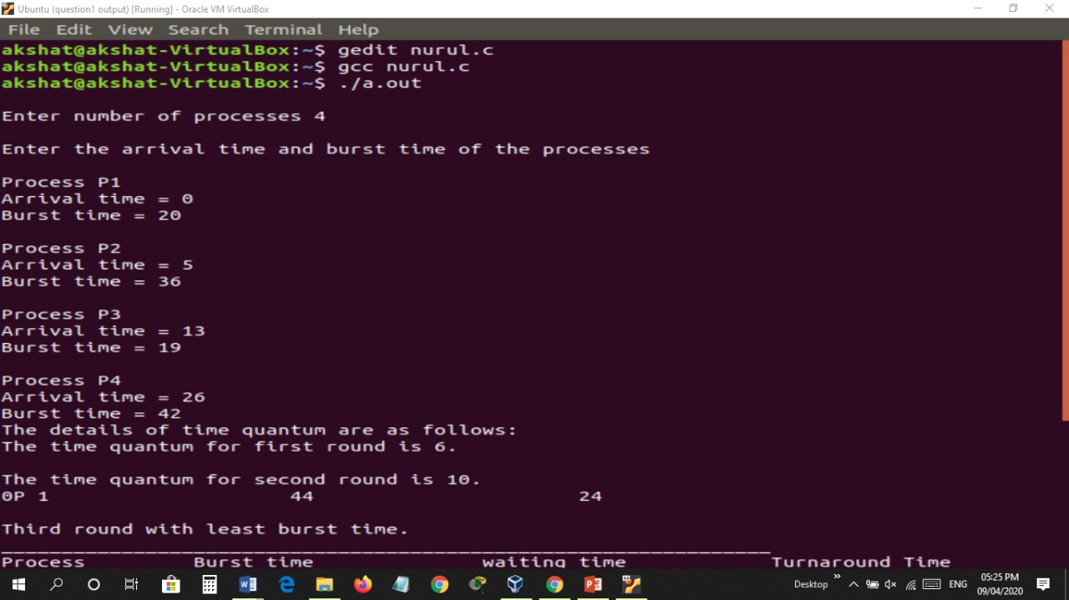

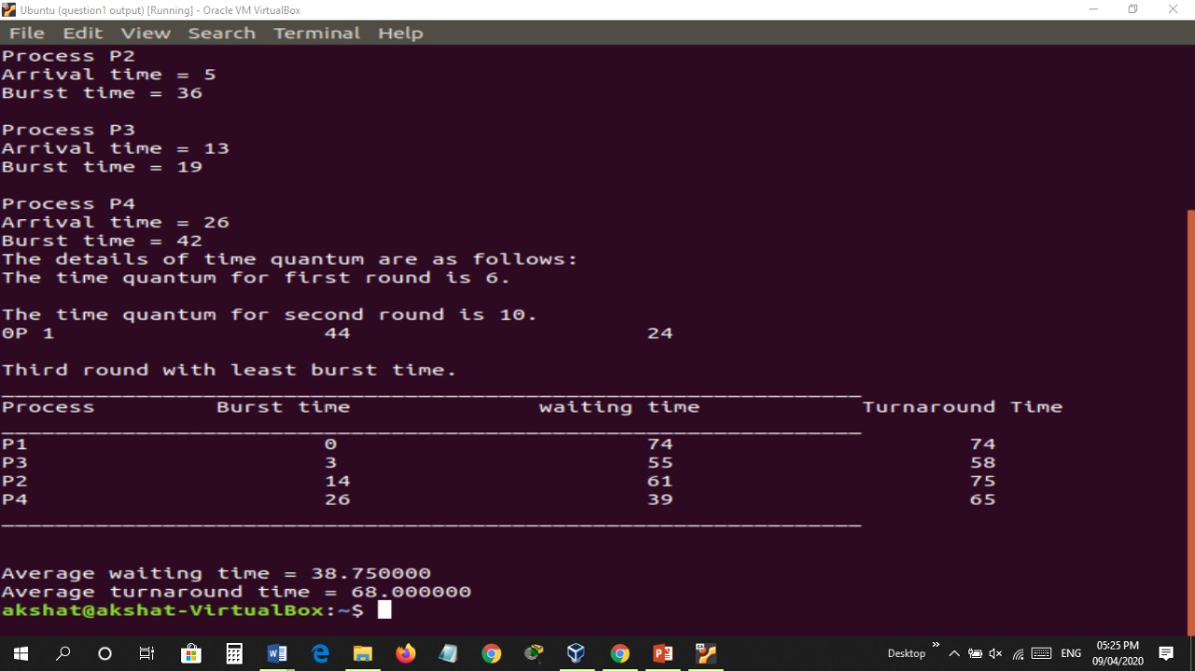

EXPLANATION
Consider this following three processes:-
Process Queue Burst Time
P1 4
P2 3
P3 5
Given Time Quantum is 2 sec.
Step 1) The execution begins with process P1, which has burst time 4. Here, every process executes for 2 seconds. P2 and P3 are still in the waiting queue.
Step 2) At time =2, P1 is added to the end of the Queue and P2 starts executing.
Step 3) At time=4 , P2 is preempted and add at the end of the queue. P3 starts executing.
Step 4) At time=6 , P3 is preempted and add at the end of the queue. P1 starts executing.
Step 5) At time=8 , P1 has a burst time of 4. It has completed execution. P2 starts execution.
Step 6) P2 has a burst time of 3. It has already executed for 2 interval. At time=9, P2 completes execution. Then, P3 starts execution till it completes.
Step 7) Let's calculate the average waiting time.
Wait time :-
P1 = 0 + 4 = 4
P2 = 2 + 4 = 6
P3 = 3+4 = 7

